Experiment No:5
Date:
Aim
To design and develop a prototype model of an ATM (Automated Teller Machine) system that performs secure cash withdrawal using card verification, balance checking, transaction processing, and receipt generation.

Objective
- To authenticate the user using card and PIN.
- To verify account balance before withdrawal.
- To process secure transactions.
- To update account balance after withdrawal.
- To dispense cash.
- To generate transaction receipt.
- To model the system using UML (Sequence & Class Diagram).

Components Used
Hardware Components (Conceptual)
- ATM Machine
- Card Reader
- Keypad
- Display Screen
- Cash Dispenser
- Receipt Printer
- Bank Server (Backend System)
Software Components (Classes in Prototype)
- ATM
- Bank
- Account
- Transaction
- Receipt
- Card
- Customer
- Withdrawal

Modules Description
ATM Module
- Accepts card input
- Reads PIN
- Communicates with bank
- Dispenses cash
- Prints receipt
Bank Module
- Verifies card details
- Validates PIN
- Processes transaction
- Updates account balance
Card Module
- Stores card number
- Validates PIN
- Linked with account
Customer Module
- Holds customer details
- Authenticates user
Account Module
- Stores account balance
- Debit & Credit operations
- Maintains account details
Transaction Module
- Creates transaction record
- Stores transaction ID
- Updates transaction status
Receipt Module
- Generates receipt
- Prints transaction details

Working Principle (Prototype Flow)
- User inserts card.
- ATM requests PIN.
- PIN verified by Bank.
- User enters withdrawal amount.
- Bank checks balance.
- If sufficient:
  - Account debited.
  - Transaction recorded.
  - Cash dispensed.
  - Receipt generated.
- If insufficient:
  - Transaction declined.
Input
- Card Number
- PIN
- Withdrawal Amount
Output
- Cash Dispensed
- Updated Account Balance
- Printed Receipt
- Transaction Status Message
Advantages
- Secure transaction process
- Automatic balance update
- Fast service
- Error handling for insufficient balance
- Receipt generation for proof

Class Diagram
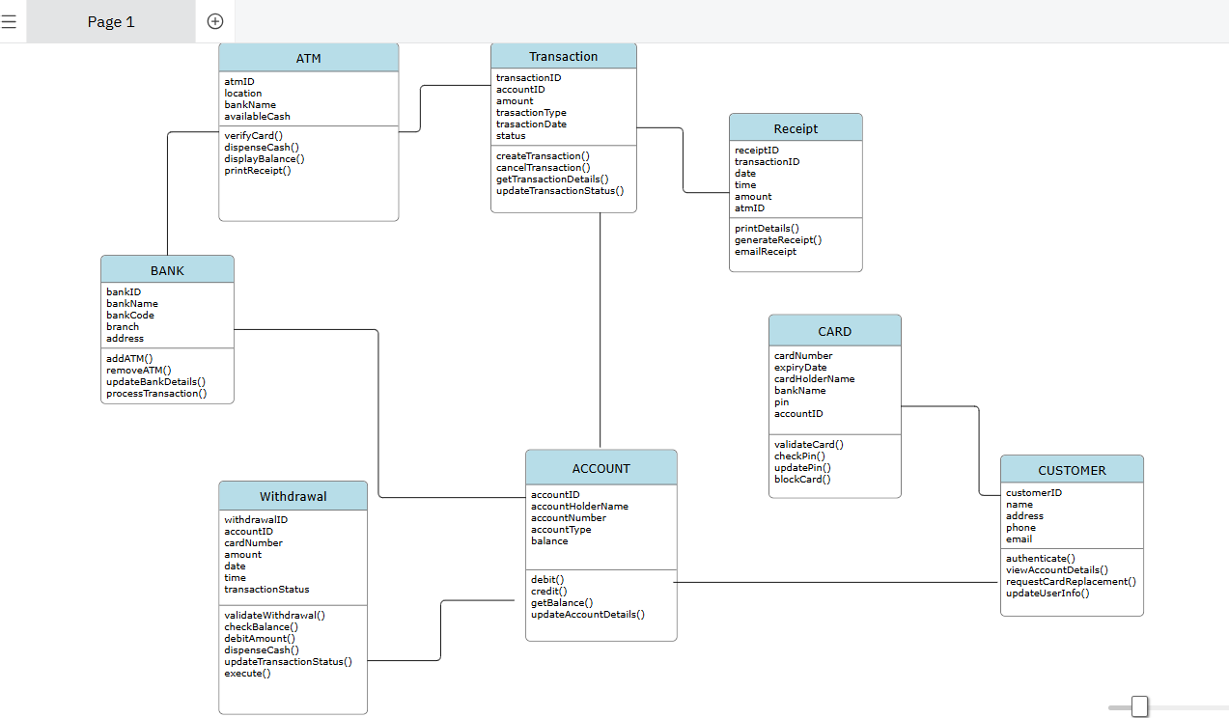
Sequence Diagram
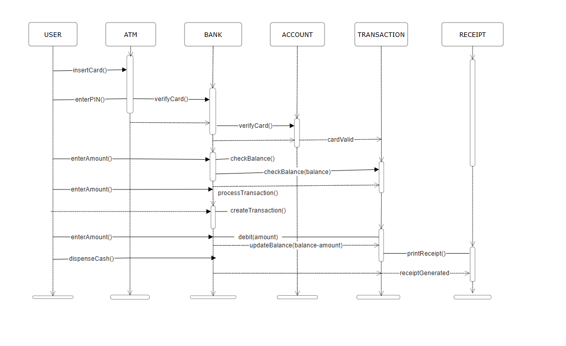Conclusion
The ATM prototype successfully models a secure banking transaction system using object-oriented design principles and UML diagrams. It ensures authentication, validation, transaction processing, and receipt generation in a structured manner.

